Class-3

Source code management tools

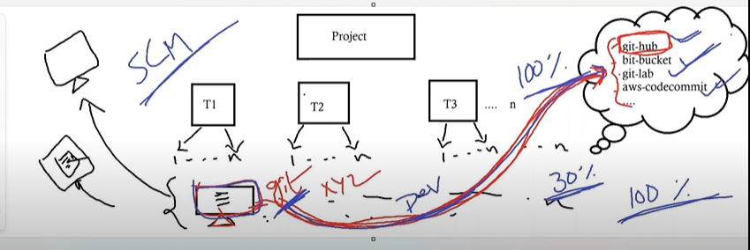

Project is divided in to many teams by dev leads because entire code of the project is not developed by one developer

Each team has many persons working

They will implement the code based on their task in their local machines

Then they have to share the code to devops team and it is difficult to share in other means(pendrive, shared drive, mails etc..,) and even if they share any updations will be difficult

So they upload it in to centralized repository like git-hub ,bit bucket , git-lab , aws-codecommit etc..,

Advantages-

* Code can be accessed easily
* We can manage code very well in various versions
* Tracking of developers modifications (reason, author name , mail etc..,)

To upload this code or to access this code we have to install git software in their local machines so that they can upload in all the repositories.

After installing git in our local machine we can open git bash in respective path

We have to configure the username and email to track the changes in our name

We have to create password for uploading purpose into git hub

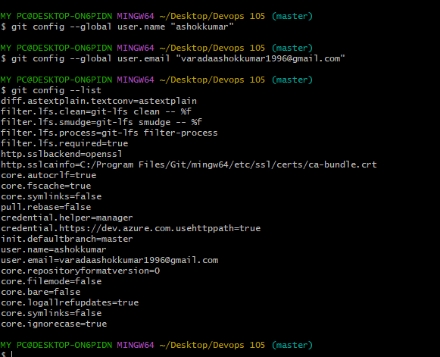

To replace username we can use same command

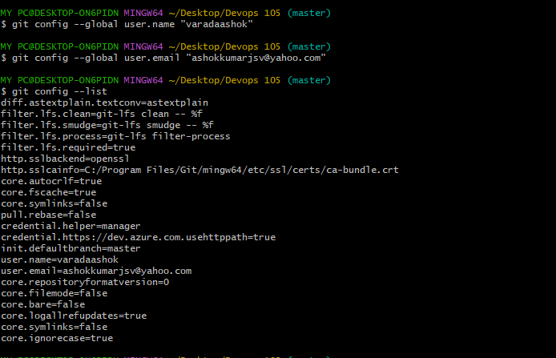

We can remove the user and email by using the below command

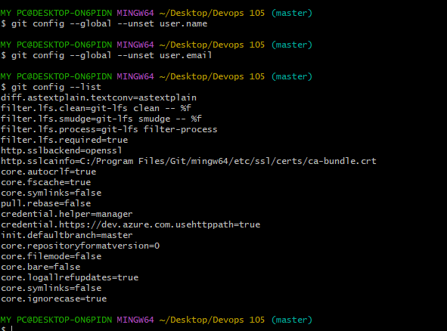

Class-4

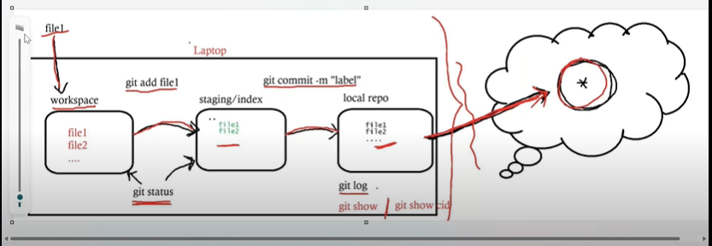

For every new folder or directory we have to initialize git again by using gitinit command

There will be stages in Git of our local machine before uploading in to github

1.workspace

Any file created will be in our workspace and we have to move it to staging because author details will be captured and tracked. Files in workspace will be in red colour and heading will be untracked files

Git add <file name>

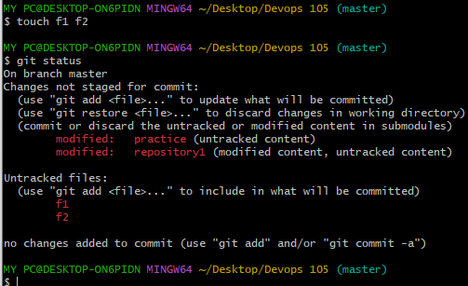

2.staging/indexarea

File should be uploaded to local repository because file can be uploaded only from local repository by using command-

git commit -m "lable name"

Files in the staging will be in green colour and heading will be changes to be commited

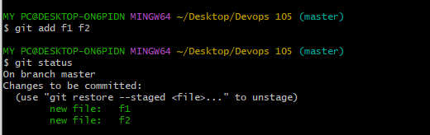

3.local repository

Any files should go through these stages before uploading in to git hub

We can see the files in local repository by using git show command git show cmt id

And git log to check the actions taken and details

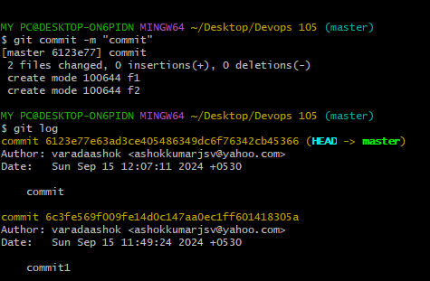

Shaw code or commit id will be created once we commit any changes

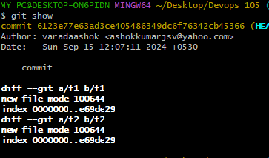

We can move file from staging to workspace by using command

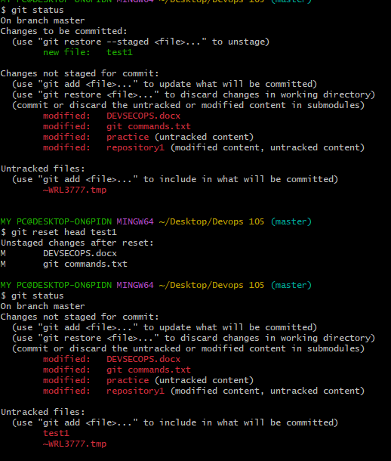

We can move file from local repo to staging by using command

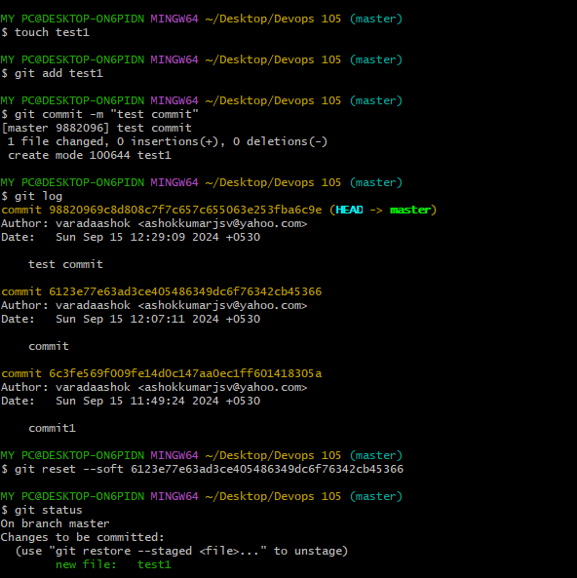

Class -5

Git hub account and repository creation and data uploading

We have to create a github account and click on new repository

Check on add a readme file to initialize without gitinit command

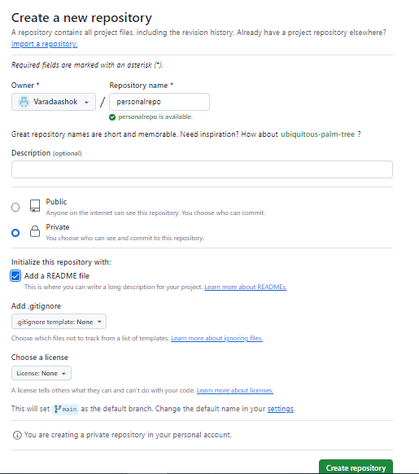

Click on create repository

* Upload data in git hub account

Copy the code of repository and clone the repository into local machine then we can upload the files

Change the directory to repository

Add files or modify files

Git status

Git add file1

Git commit –m “first commit”

Git push

It will ask credentials and after authorization files will upload